E-commerce Growth Analysis

(COMP3125 Individual Project)

Richard Wu

Abstract

Over the past few years, e-commerce has expanded quickly, altering how consumers browse and engage with brick-and-mortar stores. This project analyzes how e-commerce is growing as a percentage of total retail, looks at the rise of worldwide e-commerce sales, and determines which regions are driving this increase. This research uses Statista data to highlight important trends and insights about the future direction of e-commerce and the elements that make it successful.

Keywords:

* E-commerce
* Retail growth
* Global trends
* Market analysis

# INTRODUCTION

Thanks to the internet, new technology, and changes in consumer behavior, e-commerce has revolutionized the way people purchase in recent years. The global adoption of e-commerce was also significantly accelerated by the COVID-19 epidemic. This study looks at how e-commerce has expanded around the world, which nations and areas are driving this trend, and what the data indicates about its prospects.

Key Research Questions:

1. How have global e-commerce sales grown in the last five years?
2. What percentage of total retail sales does e-commerce represent worldwide, and how has this share evolved?
3. Which countries have shown the highest revenue growth in e-commerce over the past few years?

The findings provide stakeholders with insights into the dynamics of the e-commerce market, offering opportunities for future growth.

1. Datasets

A. Sources of Data

1. Worldwide Retail E-Commerce Sales  
   Source: [Statista](https://www-statista-com.ezproxywit.flo.org/statistics/379046/worldwide-retail-e-commerce-sales/)  
   Description: Global sales data tracking the growth of e-commerce over time.
2. E-Commerce Share of Retail Sales Worldwide  
   Source: [Statista](https://www-statista-com.ezproxywit.flo.org/statistics/534123/e-commerce-share-of-retail-sales-worldwide/)  
   Description: Data showing e-commerce's share of total retail sales globally.
3. Revenue Growth in E-Commerce for Selected Countries  
   Source: [Statista](https://www-statista-com.ezproxywit.flo.org/statistics/266064/revenue-growth-in-e-commerce-for-selected-countries/)  
   Description: Regional and country-specific revenue growth trends for e-commerce.

B. Characteristics of the Dataset

* Format: Tabular datasets (.csv) containing annual sales, percentages, and revenue growth metrics.
* Features:
  + Year (time series)
  + Global sales ($ billions)
  + Share of total retail (%)
  + Country/Region-specific revenue growth (%)
* Preparation:
  + Data Cleaning: Handling missing values and standardizing units.
  + Feature Engineering: Calculating yearly growth rates and aggregating regional data.

1. **Methodology**

**Tools and Techniques**

* **Python Libraries**:
  + **Pandas** for data manipulation.
  + **Matplotlib and Seaborn** for visualizations.
* **Calculations**:
  + Year-over-year growth rates.
  + Regional comparisons for e-commerce penetration.
* **Models**:
  + Time series forecasting with Prophet to predict future trends.
  + Clustering using K-Means to group countries based on growth and adoption rates.

1. Results

A. Global E-Commerce Sales (2017–2027)

* Observation:  
  From $1.5 trillion in 2015 to an estimated $8 trillion by 2027, e-commerce revenues have increased steadily. This illustrates the sector's explosive growth, since it represents a five-fold increase over 12 years.

B. E-Commerce as a Percentage of Total Retail Sales (2021–2027)

* Observation:  
  E-commerce's percentage share of overall retail sales increased from 18.8% in 2021 to a predicted 22.6% by 2027, demonstrating the growing global adoption of online sales in the retail industry.

C. Leading Countries in Retail E-Commerce Growth (2023)

* Key Insights:
  + Mexico leads with a growth rate of 25.1%, followed by the Philippines (24.1%) and Malaysia (18%).
  + Significant increase is seen in emerging markets such as Argentina, Brazil, and India, indicating unrealized potential in these areas.
  + Despite attaining growth of 11.4%, China's market is maturing in contrast to its previous double-digit expansion rates.

Visualizations

1. Global E-Commerce Sales Trend (2017–2027)
   * Line graph depicting sales growth from 2017 to 2027.
   * Trend shows consistent year-over-year growth, with marked acceleration post-2020 due to pandemic-driven digital adoption.

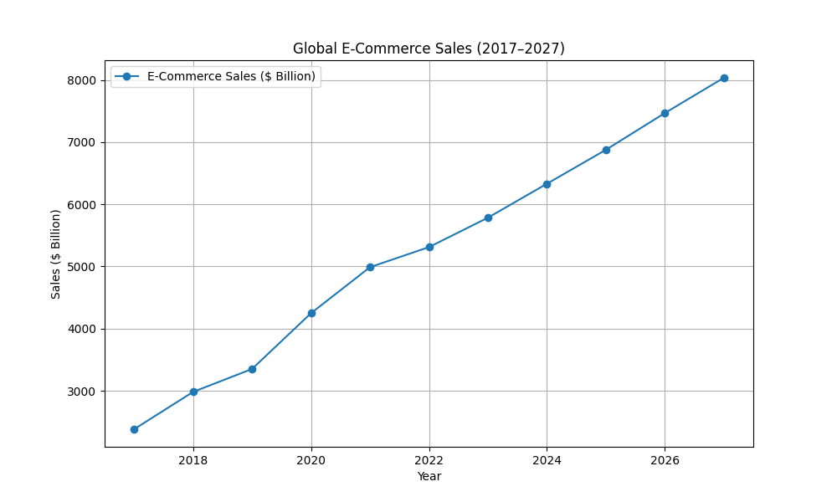

1. E-Commerce Share of Retail Sales (2021–2027)
   * Bar chart showcasing the rise in e-commerce as a percentage of total retail sales, emphasizing the increasing role of online channels.

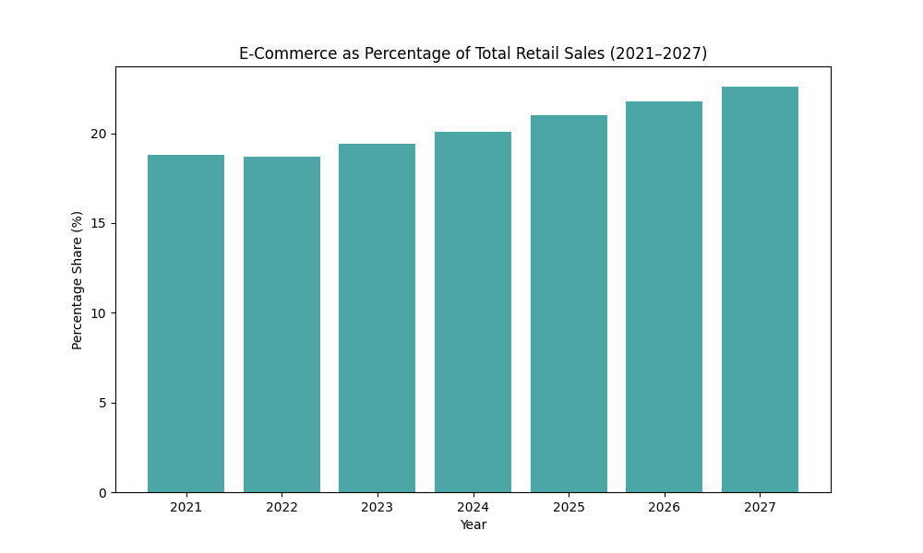

1. Top 10 Countries for E-Commerce Growth in 2023
   * Horizontal bar chart comparing growth rates for leading countries, highlighting regional dynamics and growth leaders.

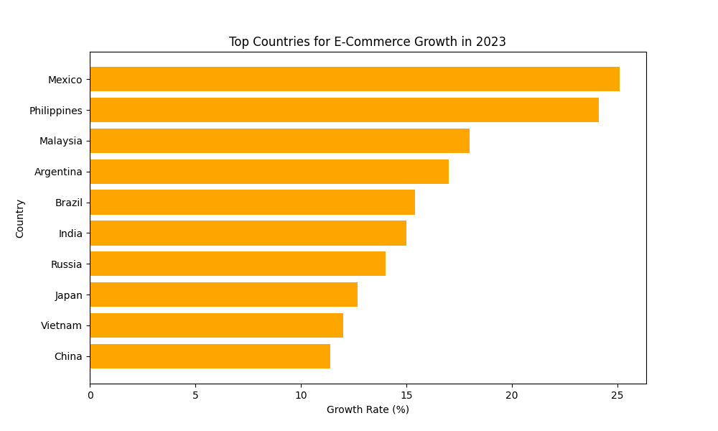

REFERENCES

Statista, "Worldwide retail e-commerce sales,": <https://www-statista-com.ezproxywit.flo.org/statistics/379046/worldwide-retail-e-commerce-sales/>.

Statista, "E-commerce share of retail sales worldwide: <https://www-statista-com.ezproxywit.flo.org/statistics/534123/e-commerce-share-of-retail-sales-worldwide/>.  
Statista, "Revenue growth in e-commerce for selected countries,": <https://www-statista-com.ezproxywit.flo.org/statistics/266064/revenue-growth-in-e-commerce-for-selected-countries/>.